Works Orders
Recording what you have manufactured
Fuse Manufacturing — user guide 04

Before you start

What a works order is
A works order is an instruction to make something: which item, how much of it, and from what. It is created before production starts and stays open until the full quantity has been made.
Recording production against it does two things at once. The components are consumed, and the finished goods are created. Both happen together, and both reach Intacct as a single operation — so you can never end up with components used and nothing to show for them.

Where the recipe comes from
Every works order points at a BOM — a bill of materials, which is simply the recipe: which components, and how much of each, to make a given quantity.
BOMs come from Sage Intacct. You never type a recipe in Fuse, and you cannot change one here. Fuse works out the component quantities for you from the BOM and the amount you are making; your job is to confirm what was actually used and correct anything that differed.

Before you record anything
- Know how much you actually made, not how much you intended to make.
- Know whether anything was substituted or used in a different quantity.
- Know which warehouse the components came from — the store, or a work-in-progress warehouse if they were issued to the floor first.

Finding the works order
- On Fuse Home, click Works Orders.
- A list opens showing the open orders: the item being made, the status, the BOM, the quantity ordered and the order number.
- Click the row you are recording against.
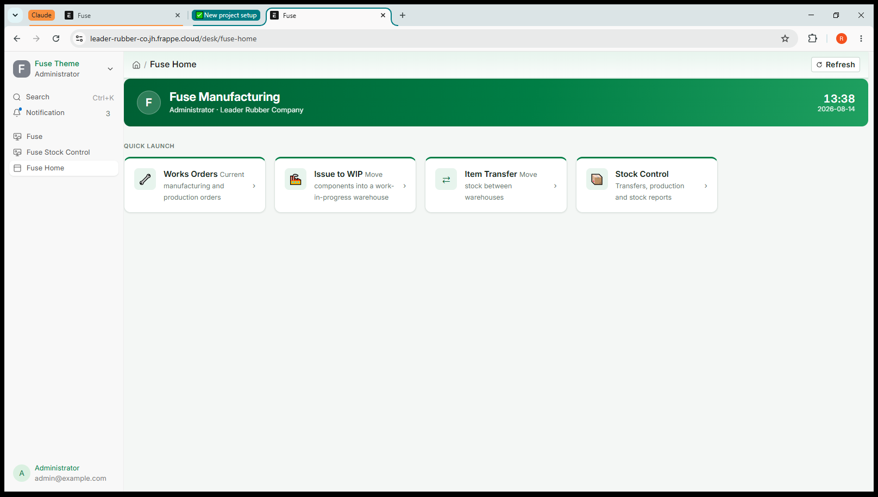
Screenshot 1 — The works orders list

Reading the works order

Field | What it tells you
Item To Manufacture | What is being made.
Qty To Manufacture | How much the order is for in total.
Manufactured Qty | How much has already been recorded against it. Starts at zero.
BOM No | The recipe being used.
Source Warehouse | Where the components will be taken from.
Target Warehouse | Where the finished goods will be put.
Required Items | The components and quantities, worked out from the BOM.

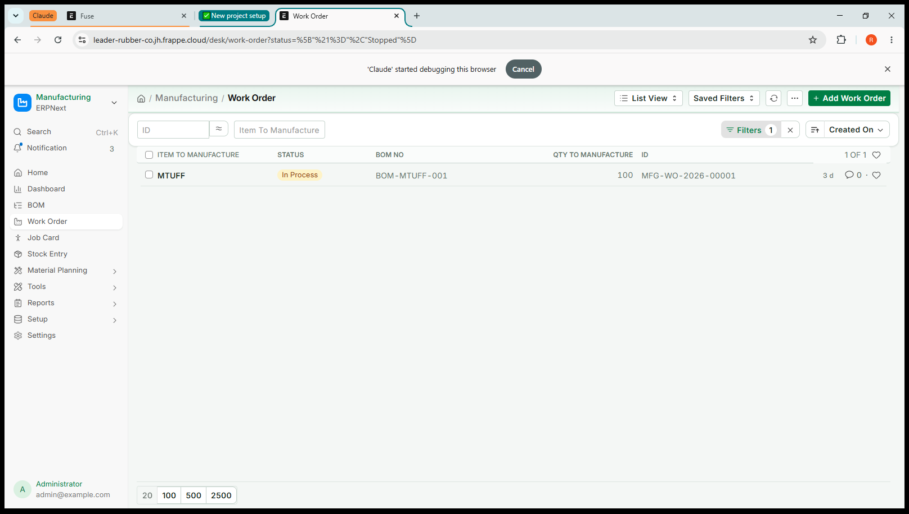
Screenshot 2 — A works order, showing quantities and warehouses
Status In Process means the order is open and can be produced against. A completed order drops off the default list.

Recording production
Do this when the batch is finished and you know how much you actually made.

Step 1 — Finish
- With the works order open, click Finish at the top right.
- A Select Quantity box appears, showing the quantity for manufacture and the maximum you may record.
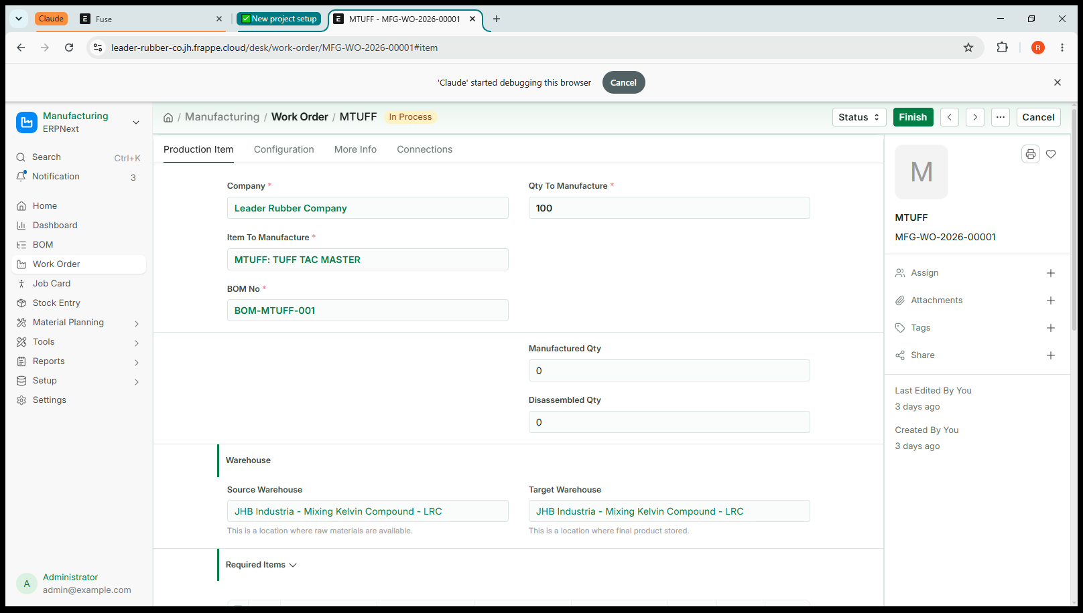
Screenshot 3 — The Select Quantity box
- Type how much you actually made. It can be less than the full order.
- Click Create.
Leave Consider Process Loss alone unless your supervisor has told you otherwise.

Step 2 — The Manufacture entry
A Manufacture entry opens, already filled in. The works order number is carried across, and every component from the recipe has been worked out for the quantity you entered.
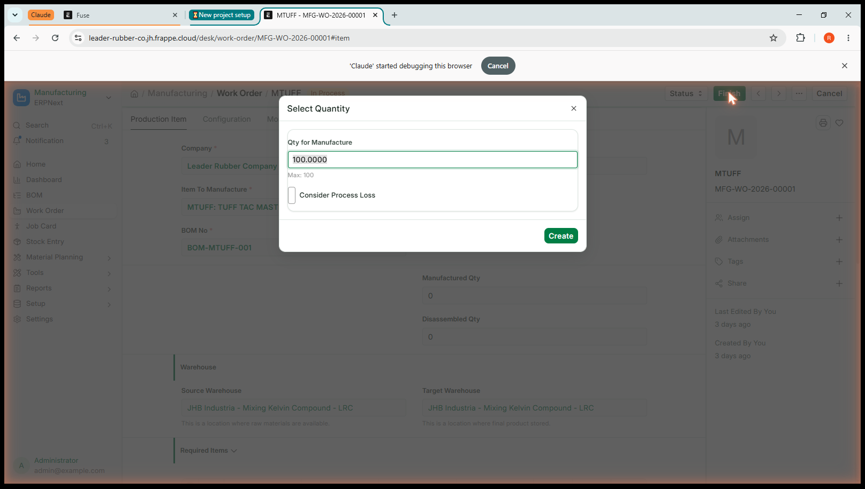
Screenshot 4 — The Manufacture entry, linked back to the works order
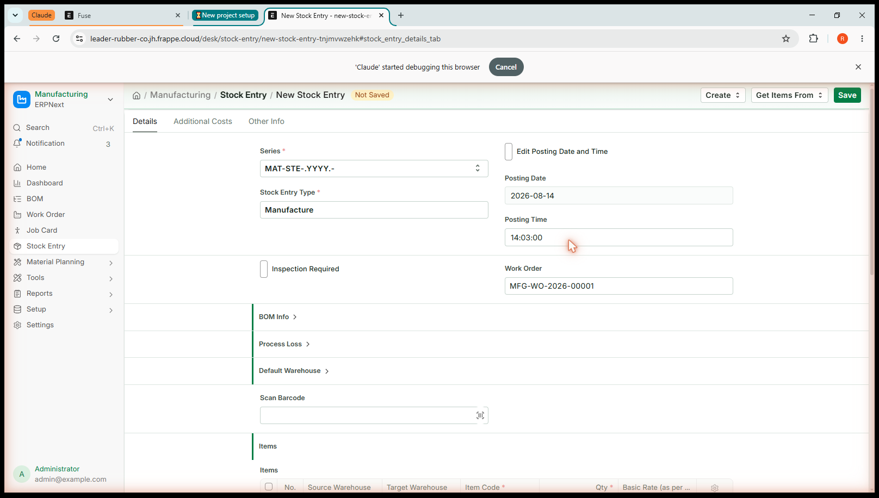
Screenshot 5 — Components worked out automatically — twelve lines for a 10 kg batch
The last row in the list is the finished goods going in. The rows above it are the components coming out.

Step 3 — Check what was really used
This is the part that matters, and the part a new operator most often rushes. What Fuse has filled in is what the recipe says should have been used. What you record should be what actually was.
- If a component went over or under, change the Qty on that row.
- If a component was substituted, change the Item Code on that row to what was really used. Fuse records the substitute, not the original — that is deliberate, and it is why adjustable recipes work.
- If an extra component was added, click Add row and enter it.
- If a component was not used at all, set its quantity to zero or remove the row.

Why the honesty matters
The cost of the finished goods is worked out from the cost of what was actually consumed. Record what really went in and the finished cost is right. Accept the recipe when it was not followed, and the cost is wrong from that point onwards — and nobody downstream has any way of knowing.

Step 4 — Save, check, submit
- Click Save. The entry is a draft. Nothing has moved.
- Read the lines once more.
- Click Submit, and confirm.
Two records go to Intacct together: the components consumed, and the finished goods produced. They are sent as one operation, so a half-recorded production run is not possible.

Producing in stages
You do not have to record a whole order at once.
If the order is for 100 kg and you made 40 kg today, record 40. The works order will show 40 made and 60 still to go. Tomorrow you record the rest, and each part reaches Intacct as it happens.
This is the normal way to work when a batch runs over more than one shift or day. There is no need to wait until an order is complete.

Checking it worked
- Go to Fuse Home and click Stock Control.
- Under Reports, open Stock Balance.
- Check the finished item has gone up by what you made, and a component or two have gone down.
- Open the works order again — Manufactured Qty should now show what you recorded.

If something goes wrong

What you see | What it means and what to do
Negative stock / not enough quantity | A component is not available in the source warehouse in the quantity shown. Check the warehouse is right — if the components were issued to the floor, they are in a work-in-progress warehouse, not the store.
Quantity must be positive | A row has zero or a blank quantity. Enter it, or remove the row.
This entry produces more than one finished item | Only one finished item per entry. Record the other on its own entry.
A component is produced but is not the finished item | A row has a destination but no source. Scrap and by-products are not handled yet — speak to your supervisor.
Intacct rejected the request | Nothing has been recorded anywhere. Read the reason; if you cannot fix it, send it to your administrator.

Two rules that apply to everything in Fuse

Saving is not submitting
Saving stores a draft. A draft changes no stock at all, in Fuse or in Sage Intacct, and you can edit it, leave it, or delete it freely. Nothing has happened yet.
Submitting is the moment it becomes real. Fuse sends the movement to Intacct, and only once Intacct has accepted it does Fuse record it here. Read your work between the two.

Cancel, never delete
If you get something wrong after submitting, open the document and choose Cancel. Fuse reverses the movement in Intacct first, then cancels it here, so both systems return to where they were.
Do not delete, and do not try to correct a mistake by entering a second, opposite movement. Deleting would remove the record here while Intacct still holds the movement, and an opposite entry leaves two wrong movements in the history instead of none.

Why the two systems cannot disagree
Fuse and Sage Intacct hold the same stock. Fuse always sends the movement to Intacct first and waits for it to be accepted. If Intacct refuses, nothing is saved in either system and the reason appears on screen. That is why you never enter anything twice, and why nobody has to reconcile the two afterwards.
Cancelling a production run reverses both halves in Intacct: the finished goods come back out, and the components go back in at the cost they left at. The works order returns to the position it was in before.

Jobs that belong in Intacct
Fuse will stop you doing these, with a message explaining why. Nothing is saved and nothing is broken — the job simply belongs in the other system.

If you try to | What happens
Receive goods from a supplier | Refused. Goods receipting is done in Intacct. Fuse shows what is on order so you can plan, but the receipt is recorded there.
Adjust stock up or down | Refused. On-hand corrections are made through a Cycle Count in Intacct.
Change an item, warehouse or supplier | Read-only here. These come from Intacct, and a change made in Fuse would be overwritten at the next sync.

Quick reference
Fuse Home → Works Orders → open the order → Finish → quantity → Create → check the components → Save → Submit.

Question | Answer
Can I record part of an order? | Yes. Record what you made; the rest stays open.
Can I change a component? | Yes. Change the quantity or the item code to what was used.
Do I work out the quantities? | No. Fuse takes them from the BOM. You correct them.
Do I enter a cost? | No. It is worked out from the components consumed.
Where do BOMs come from? | Intacct. They cannot be edited in Fuse.
Two finished items on one entry? | No. One each.
How do I undo it? | Cancel the Manufacture entry. Both halves are reversed.

Where this goes
Fuse and Sage Intacct hold the same stock. Anything you submit here is sent to Intacct immediately, and Fuse only records it once Intacct has accepted it. If Intacct refuses, nothing is saved in either system and you will see the reason on screen.

